The Value of location: What Matters Most for Older Adults Considering Relocation in Sweden?
Nick Christieª , Björn Slaugª, Magnus Zingmark^{abc}, Jonas Björk^{de}, and Susanne Iwarssonª

ªDepartment of Health Sciences, Faculty of Medicine, Lund University, Lund, Sweden; ^{b}Health and Social Care Administration, Municipality of Östersund, Östersund, ^{c}Community Medicine and Rehabilitation, Umeå University, Umeå, Sweden;
^{d}Clinical Studies Sweden, Forum South, Skåne University Hospital, Lund, Sweden;
^{e}Division of Occupational and Environmental Medicine, Lund University, Lund, Sweden

For correspondence, please contact Nick Christie, nick.christie@med.lu.se

Nick Christie is a postdoctoral researcher and research engineer at Lund University. His research bridges health sciences and economics, focusing on housing, urban planning, and ageing, with particular attention to relocation patterns among older adults.
Björn Slaug is an Associate Professor of Health Sciences at Lund University and a member of the Active and Healthy Ageing research group at the Centre for Ageing and Supportive Environments (CASE). His research focuses on the built environment and how it can be adapted to support active and healthy ageing.
Magnus Zingmark is an Associate Professor in Occupational Therapy at Umeå University and affiliated researcher at Epidemiology and Global Health, Umeå University. His work focuses on health promotion, falls prevention, and reablement for older adults, and he leads R&D for active and healthy ageing in the Municipality of Östersund.
Jonas Björk is a Professor of Epidemiology at Lund University. His research focuses on sociodemographic differences in health and wellbeing, using population-based data, and he contributes to developing infrastructure for population research and public health surveillance.
Susanne Iwarsson is Professor of Gerontology and Care for Older People at Lund University and Doctor Honoris Causa at Riga Stradins University, Latvia. Her research in environmental gerontology focuses on ageing, health, housing, and participation, and she is the founding director of the Centre for Ageing and Supportive Environments (CASE) and the Swedish National Graduate School on Ageing and Health (SWEAH).

Research Aim | - To explore willingness-to-pay estimates of preferred locational attributes for older individuals in Sweden considering relocation.  - Explore heterogeneity in locational preferences for older individuals in Sweden considering relocation.  - To identify differences in willingness to pay estimates famong older individuals considering relocation in Sweden.
Journals | - Housing studies – Have published a handful of studies using a DCE. Good candidate  - Journal of housing and the built environment. (latex) good candidate https://link.springer.com/journal/10901  - Nature Ageing – appears to be rooted in medical science (DNA sequences, biological indicators, etc). No DCE studies identified. Low candidate  - Lancet – No DCE studies found – low candidate  - Health and Place - ?  - Urban Studies - ?  - Ageing Studies - ?
Methodological approach | - Estimate mixed logit models on Renters and Owners to identify MWTP estimates  - Extend these models to include interaction terms which facilitate identifying differences across age, gender, and health.
Methodological considerations | - Our primary focus is on tenure groups. We could shift this to another group – age groups perhaps – to move the focus of the paper.  - The heterogenous tests identify some significant differences, but they are not very strong. Exploring alternative groups could produce stronger results. (retired, civil status, city center vs urban environment, etc)
Paper structure consideration | - Perhaps combine the introduction and literature review sections?  - Convert SEK to Euro for international audience?

The Value of location: What Matters Most for Older Adults Considering Relocation in Sweden?
We examined heterogeneity in housing preferences among older adults in Sweden using discrete choice experiment data (n = 957; mean age = 72; 55.3% women). Respondents assessed trade-offs between key residential attributes, including proximity to shops and services, green spaces, access to public transportation, dedicated parking, and planned monthly expenses. We estimate mixed logit models to recover marginal willingness to pay estimates for each attribute, including interactions with age, gender, and health to capture systematic variation in preferences. The results show that individuals in the oldest age groups expressed significantly higher willingness to pay for several attributes, with values around 1.5 times greater than those of younger respondents. We identified meaningful differences by gender and tenure status, reflecting underlying patterns of social inequality in later life. These findings contribute policy-relevant evidence to support the development of age-inclusive housing strategies that address both diverse preferences and structural disparities in residential choice.
Keywords: stated choice; discrete choice; ageing in place; housing; housing preferences

Introduction
Population ageing is reshaping housing markets and welfare systems across much of the developed world. By 2050, the number of people aged 65 years or older is projected to more than double from 2021 levels, rising to 1.6 billion individuals (United Nations Department of Economic and Social Affairs, 2023). As the proportion of older adults continues to rise, policymakers face growing challenges in ensuring that housing and neighborhoods support autonomy, accessibility, and wellbeing in later life. Although most older adults prefer to age in place, remaining in familiar environments rather than relocating to institutional care (Wiles et al., 2012; Abramsson & Andersson, 2015), life-course events and declining physical capacity often necessitate or motivate residential change. Understanding how older individuals evaluate potential relocation alternatives is therefore essential for developing effective, age-inclusive housing strategies.
Relocation decisions in later life are shaped by a complex interplay of personal, social, and environmental factors (Roy et al., 2018). At older ages, maintaining a dwelling may become burdensome, while multi-level homes or inaccessible layouts may no longer fit changing functional abilities (Ewen et al., 2014). The departure of children or the loss of a partner can alter household needs and attachment to place (Abramsson & Andersson, 2012) while reduced mobility and increased social integration alter expectations of relocation (Robison & Moen, 2000). As the home is typically the greatest source of household’s net worth, financial considerations, including the desire to release housing equity or lower housing costs after retirement, may also encourage relocation (Clark et al., 2006). Psychological factors such as loss aversion may further reinforce reluctance to move, as individuals weigh potential losses in comfort, familiarity, or community more heavily than prospective gains (Ossokina & Arentze, 2022). Nevertheless, relocation rates among older adults remain low, reflecting strong place attachment, social ties, and perceived risks associated with moving (Abramsson & Andersson, 2015).
When relocations do occur, they inevitably involve evaluating a range of neighbourhood and accessibility characteristics that influence daily life. The residential environment affects not only physical mobility and independence but also opportunities for social contact and recreation. Older adults considering relocation must therefore weigh multiple trade-offs among desirable attributes. For instance, some may prioritise proximity to green areas, while others place greater value on access to public transport or nearby shops and services. These preferences, and the implicit trade-offs they entail, are likely to vary systematically across socio-demographic groups.
The aim of this study is to explore these residential trade-offs by examining willingness to pay values of key locational and amenity attributes of older adults in Sweden considering relocation. Using data from a large-scale discrete choice experiment embedded in the Prospective RELOC-AGE project, we estimate mixed logit models to derive marginal willingness-to-pay (MWTP) measures for the following preferred housing attributes proximity to green space, shops, and public transport, as well as for access to dedicated parking. We further examine heterogeneity in preferences by age, gender, and health status to identify systematic variation in the valuation of these attributes. In doing so, the study builds on recent stated choice housing studies (Ossokina et al., 2020; Caplan et al., 2021; Ossokina & Arentze, 2022; Aitken et al., 2024; Lee et al., 2025), extending discrete choice methods to a Scandinavian context where ageing-in-place policies are well established but evidence on relocation preferences remains limited. By linking relocation motivations to the economic valuation of locational factors, the study offers policy-relevant insights into the housing needs of an ageing population and contributes empirical evidence to guide the planning of inclusive, adaptable living environments that support independence and quality of life in later life.

Literature Review – WORK IN PROGRESS
Population ageing is increasingly shaping the future demand for housing, both in terms of quantity and suitability. Older adults spend a greater share of their time at home and rely on their residential environment for daily functioning, social contact, and wellbeing (SOURCE). The concept of “ageing in place” has become central to housing policy in many places across the world, emphasizing the desire of older adults to remain in familiar surroundings for as long as possible. (SOURCE). However, a key pillar of ageing in place depends on the suitability of existing housing and the availability of accessible alternatives when relocation becomes necessary.
Despite growing recognition of these issues, empirical evidence on how older adults value specific residential attributes remains limited. Much of the literature has focused on life-course transitions, housing tenure, and affordability (SOURCES), but relatively few studies quantify trade-offs among housing and locational characteristics.

DCEs represent a specific and widely used form of stated choice methodology. Respondents are presented with choice sets containing two or more alternatives that vary systematically across predefined attributes, and they select their preferred option in each set. The approach is rooted in random utility theory which assumes that individuals choose the alternative that maximizes their utility based on observable attributes and unobserved factors (McFadden, 1974). By observing patterns of choice across multiple scenarios, researchers can infer the relative importance of different attributes and estimate willingness-to-pay (WTP) values when a cost attribute is included. This capacity to quantify trade-offs makes DCEs particularly valuable in housing research, where individuals must balance multiple, often competing, considerations such as price, location, accessibility, and amenities.
Discrete choice experiments (DCE) have been used in a variety of housing and ageing studies. Ossokina et al. (2020) estimate a stated choice experiment to study the residential preferences of elderly homeowners in the Netherlands, reporting that residential attributes connecting to safety and social cohesion play an important role for the elderly. Ossokina and Arentze (2022) examine reference-dependent housing choice behavior among older adults, finding that proximity to public transport and shops significantly influences residential decisions.
Applications of DCEs to housing have expanded considerably in recent decades. Early studies focused primarily on environmental amenities and locational factors, such as proximity to green spaces, transit, and urban services (Earnhart, 2002; Cho et al., 2005; Liao et al., 2015). More recent work has integrated socio-demographic and behavioral factors to explore heterogeneity in preferences across population subgroups. For example, Caplan et al. (2021) examined residential preferences along Utah's Wasatch Front and found substantial variation in willingness to pay for amenities such as green space and access to transit. Ossokina and Arentze (2022) demonstrated that housing decisions among older homeowners are reference-dependent, showing how individuals in the Netherlands value safety, accessibility, and social cohesion relative to their current housing situation. Similarly, Lee et al. (2025) analyzed willingness to pay for circular and affordable housing among younger adults in South Korea, while Ardeshiri et al. (2024) used a dual DCE to distinguish between preferences for owner-occupied and investment properties in Sydney.
Housing preferences are rarely uniform across individuals. Economic capacity, household composition, tenure status, and health conditions can all shape how people evaluate residential alternatives. Studies have shown that income influences willingness to pay for proximity and comfort amenities, while tenure reflects differences in security, attachment, and investment orientation (SOURCES). Ageing itself introduces new dimensions of heterogeneity, as physical ability, mobility, and social networks evolve over time (Lofqvist et al., 2013). To capture this systematic variation, recent DCE studies have incorporated interaction terms and advanced econometric specifications (Caplan et al., 2021; Aitken et al., 2024; Schulz et al., 2025). These studies demonstrate that preferences for attributes such as proximity to amenities, green space, and transport depend strongly on income, age, and household characteristics. Such methods are particularly suitable for studying diverse populations like older adults, whose housing preferences may differ systematically by age, health status, income, or tenure arrangement.
However, the evidence base for older populations remains thin, and most findings are context-specific, reflecting local housing systems and welfare regimes. Few studies have explicitly focused on older populations or systematically examined heterogeneity within this demographic. Most DCEs on housing preferences have been conducted among general adult samples, leaving considerable uncertainty about how preferences change with age, retirement, or tenure transitions. Moreover, applications of DCE in Scandinavian contexts remain rare. This gap is particularly consequential given the rapid ageing of populations across developed countries and the distinct housing systems and welfare regimes that characterize different national contexts.
This study contributes to closing this gap by employing a DCE embedded within a large, national sample of older adults in Sweden. By combining a robust experimental design with mixed logit modelling, we identify key determinants of housing preferences and quantify their associated willingness-to-pay values across diverse subgroups. Specifically, we examine how preferences for proximity to green areas, shops, public transport, and parking amenities vary systematically by age, gender, and tenure status among individuals actively considering relocation. In doing so, the study adds new empirical evidence to the literature on ageing and housing, demonstrating how demographic and economic differences translate into distinct patterns of residential choice within an ageing population. The findings offer policy-relevant insights for developing age-friendly housing strategies that accommodate heterogeneous preferences and address structural disparities in housing access among older adults.

Materials and Methods
This study used a DCE to examine the housing attribute preferences of older adults in Sweden who are considering relocation in the context of the Prospective RELOC-AGE project.

Participants and data collection
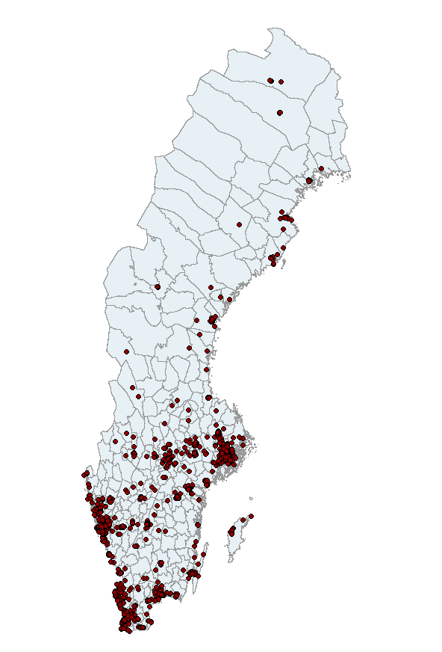
Survey and experiment data was derived from the Prospective RELOC-AGE project, a longitudinal two-tiered mixed-method cohort investigation conducted in Sweden. The project was registered under the identifier NCT04765696 on ClinicalTrials.gov (U.S. National Library of Medicine, 2021). A geographically diverse sample of individuals aged 55 and above was recruited across Sweden (see Figure 1).
Figure 1
The primary objective of the Prospective RELOC-AGE study was to explore the long-term dynamics associated with housing choices, relocation, and active and healthy ageing, focusing on individuals across the ageing process. Eligible participants were individuals aged 55 or older, residing in Sweden, and actively registered for relocation with one of three housing companies: two local public housing providers and a national provider of tenant-owned dwellings. Data collection for this study was conducted in conjunction with the second follow-up survey administered in May 2024.
The choice experiment was administered in conjunction with the follow-up Prospective RELOC-AGE survey in May 2024, where 1,247 respondents agreed to participate in the survey via a web-based platform. After the main survey was completed, respondents were asked to take part in the optional DCE. Following the initial survey administration, two reminder emails were sent out to encourage participation in the DCE. The first in September 2024, to the entire respondent group, and another reminder in October 2024, targeting only those who had not taken the experiment portion of the survey. This resulted in an 80% increase from initial turnout. The final sample size of 957 individuals was finalized, representing a 73% response rate.
Prior to administering the DCE, we conducted an internal review and a pilot study to review the experiment (n = 20; n = 56). The internal review involved researchers and staff within the University's network. The second pilot was administered to participants in Lund University's Intressenpoolen, a network of individuals collaborating with academia and society in the areas of ageing and health. In both studies, respondents completed the experiment and a structured feedback form assessing the relevance of attributes, clarity of wording and levels, and overall task comprehension and burden. Feedback was instrumental in refining the experiment and clarifying the descriptions and wording of the instructions. We made several informed revisions: clarifying attribute descriptions and levels; removing redundant instructional text; fine-tuning attribute ranges; and reducing the number of choice sets to manage respondent burden.
The final design included three parts: an introduction to the experiment while defining the attributes and levels, a short questionnaire on household income, costs, and planned future housing costs; and the experiment with nine choice sets.

Experiment design
Stated choice experiments encompass a range of techniques in which respondents indicate their preferences by explicitly stating their choices. In contrast to revealed choice experiments, where preferences are inferred from past behavior, stated choice methods allow for the evaluation of decisions in a controlled environment. This controlled setting enables researchers to systematically manipulate attributes and isolate the impact of specific factors on decision-making (Hensher et al., 2015). A DCE is a type of stated choice model that presents individuals with hypothetical scenarios, allowing researchers to quantify how much value respondents place on different attributes of a product, service, or housing option.
In our experiment, respondents were asked to choose the most desirable housing option from a set of alternatives containing varying levels of attributes. Each respondent was presented with nine choice scenarios, where each choice set contained various levels of the included housing attributes. Figure 2 depicts a typical choice set presented to the respondents.

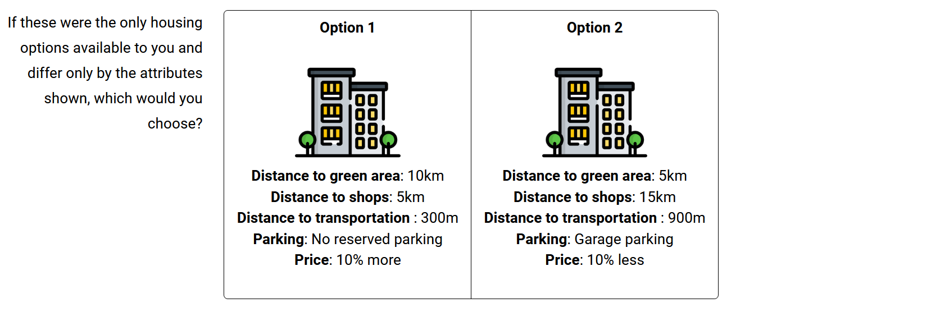
Figure 2
The choice of attributes and associated levels in our study was guided by a combination of factors identified from the Prospective RELOC-AGE follow-up study and attributes identified in the housing literature. The selected attributes reflect key elements of housing and neighborhood quality that are particularly relevant for older adults' quality of life and residential satisfaction.
Green space proximity has been examined in numerous contexts including improved cardiometabolic and general health (Maas, 2006; Paquet et al., 2013), lower stress (Nielsen & Hansen, 2007), and improved mental health (Sturm & Cohen, 2014; Cohen-Cline et al., 2015). The attribute greenspace is defined as the distance in kilometers to green areas including parks, forests, hiking areas, and open spaces. Proximity to shops and services represents not only distance to frequent amenities which may become more burdensome to traverse with age but also constitutes an integral social experience to participate in the social life of communities (Lucas et al. 2016). The attribute shops represent the distance to shopping amenities such as grocery stores, malls, boutiques, and shopping centers. Access to public transportation has been shown to affect accessibility levels of populations, with significant differences identified in senior cohorts (Alsnih & Hensher, 2003; Hildebrand, 2003; Ricciardi et al., 2015). The attribute transport is the distance to transportation, such as a bus stop, metro station, or train station. Parking availability may also affect acceptability, particularly for our sample where over 90% of respondents indicated access to an automobile.
Table 1 shows the attributes and their corresponding levels used in the experiment.

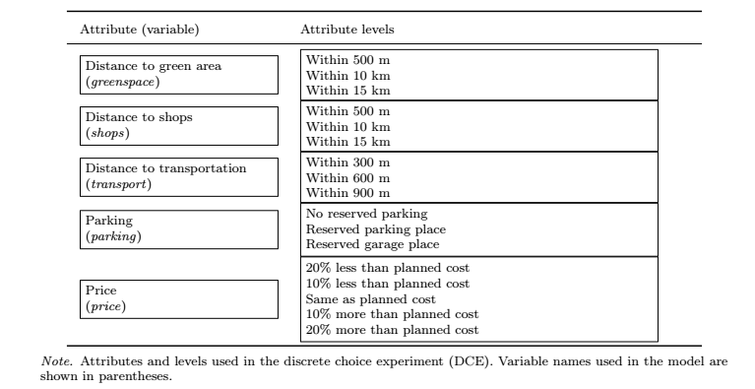
Before commencing the experiment, respondents were given a definition of each attribute, as well as an example to clarify any ambiguity in interpretation. Respondents were also instructed to base each choice on the assumption that the alternative housing options were identical in every way aside from the attributes presented. The number of choice sets for each person (?) was limited to 9 in order to minimize the cognitive burden of the DCE while maximizing the statistical power of our tests (DeShazo & Fermo, 2002; Mangham et al., 2009; Himmler et al., 2021).
The DCE data generating process is dictated by the experimental design used to construct the choice sets. Including every combination of attribute levels in the construction of the choice sets, a full factorial design is often too large to be used in practice. To reduce the dimensionality of a full factorial design, a D-optimal subset was generated that reduces dimensionality while maintaining statistical power and balanced attribute representation (Lancsar & Louviere, 2008).

Empirical models
Utilizing the discrete choice data, respondent’s choices may be modelled within a random utility theory framework, which assumes individuals choose options which maximize their utility based upon available options (Lancsar & Louviere, 2008). An underlying utility model can then be estimated where the utility that individual i derives from alternative j in a choice set t is given by:

$$U_{itj}= V_{itj}+ ε_{itj}$$
where $V_{itj}$ is the systematic component of utility, modelled as a function of the attributes of the alternative, and $ε_{itj}$is an unobserved random error term. The systematic utility is specified as:

$$V_{itj}= β1X_{itj}+ β2X_{itj}+ … + βkX_{itjk}$$
where $X_{itjk}$represents the level of attribute k for alternative j in task t, and $βk$ are the corresponding utility coefficients to be estimated. Here, $X_{itjk}$represent the respective attributes found in Table 1.
While multinomial logit (MNL) models, which assume homogeneous preferences across respondents and independently and identically distributed (i.i.d.) error terms, are commonly estimated in choice modelling, they are problematic when the objective is to uncover heterogeneity in preferences, as in our study. Recent research addresses this limitation by allowing utility coefficients to vary across individuals or groups (Caplan et al., 2021; Zhao et al., 2023; Ardeshiri et al., 2024; Aitken et al., 2024; Lee et al., 2025). We follow this line of research and estimate mixed logit (ML) models, in which the utility coefficients βi are allowed to vary randomly across individuals to account for unobserved heterogeneity in preferences (McFadden & Train, 2000):

$$β_{i}= β+ Σ_{ηi}$$
where ηi ∼ N(0,I) and Σ is the covariance matrix of the random parameters. The mixed logit model captures heterogeneity by integrating over the distribution of random coefficients using simulated maximum likelihood. Because this integral has no closed-form solution, we approximate it using simulation:

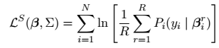
where each simulated draw βri = β + Σηir, and R denotes the number of Sobol draws used to approximate the integral over the distribution of random parameters (Train 2003). In our specification, all non-monetary attributes are treated as random and normally distributed, while the price coefficient is fixed to preserve consistency in the computation of willingness-to-pay (WTP) measures. We also allow for full covariance among the random parameters to capture potential correlations in preferences.
We then use our price coefficient to compute monetary trade-offs for non-cost attributes. First, we estimate marginal rate of substitution (MRS) for each attribute, where the MRS for attribute k is calculated as:

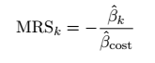
where βˆcost is the estimated coefficient on the cost attribute. Because the cost attribute is specified as a percentage change from the respondent’s expected housing cost in 10 percent intervals, we convert marginal rates of substitution (MRS) into marginal willingness to pay (MWTP) in monetary terms by scaling with 10 percent of the mean reported monthly housing cost:
$$MWTPk = MRSk × 0.10 × PC$$
where PC denotes the mean of respondents’ stated planned monthly housing cost. These MWTP estimates represent the amount, in SEK per month, that respondents are willing to pay for improvements in each housing attribute, relative to their baseline housing cost expectations.
Models are estimated in R using the logitr package (Helveston, 2023) which provides flexible estimation routines for both MNL and ML models using simulated maximum likelihood. For the ML models, we use 100 Sobol draws and multiple random starting values to ensure convergence to the global maximum (Train, 2003).

Ethics
The Prospective RELOC-AGE study was approved by the Swedish Ethical Review Authority (Dnr 2020–03457), in alignment with the Declaration of Helsinki and current national ethical regulations for research involving human participants. Potential participants received written information highlighting that participation was voluntary and that declining would not affect their access to housing options or public services. Informed consent was considered given upon the completion and return of the survey.

Results

Descriptive statistics
Table 2 provides descriptive statistics for the study sample, disaggregated by housing tenure. Of the 957 respondents, 790 were homeowners and 167 were renters. The sample was slightly majority female (55.3%), with most participants aged between 65–74 years (43.5%) followed by those aged 75+ (36.5%). The majority of respondents were partnered (60.6%), retired (77.1%), and lived in apartment or condominium housing (63.0%). Most had attained at least three years of university education (47.6%) and lived in city or town locations (62.2%). Most respondents described their health as “Good” or better (82%). Households predominantly consisted of one or two members (95.2%), with only 3.8% reporting three or more. The mean monthly household income was 46,700 SEK, and the average planned monthly housing cost was 10,500 SEK.

Table 2

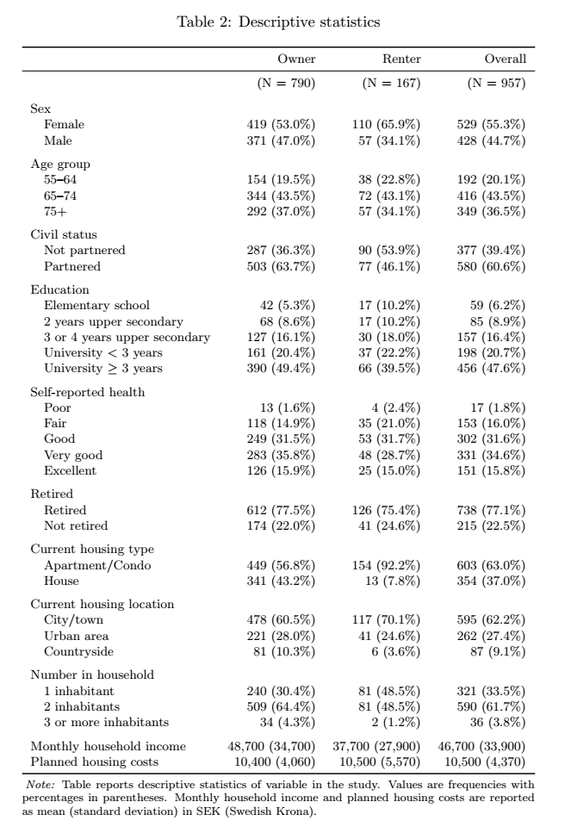

Core specification results
Our discussion begins with model results from the base specifications, which exclude interaction terms and serve as a point of comparison for subsequent models that account for heterogeneity across household types. Tables 3 and 4 present the estimation results for respondents who own and rent their housing units, respectively. In both samples, positive (negative) coefficients indicate an increase (decrease) in average utility associated with the attribute level, relative to its reference level. Reference levels are specified as the least desirable alternative to aid in interpretation.
Across both tenure groups, all estimated coefficients exhibit the expected signs and a high degree of statistical significance. For most attributes, the mean coefficients are positive, implying that closer proximity to amenities or improved neighborhood features are preferred over their reference levels. The statistically significant standard deviation estimates further confirm the presence of unobserved preference heterogeneity among households, supporting the use of the mixed logit specification.

Table 3
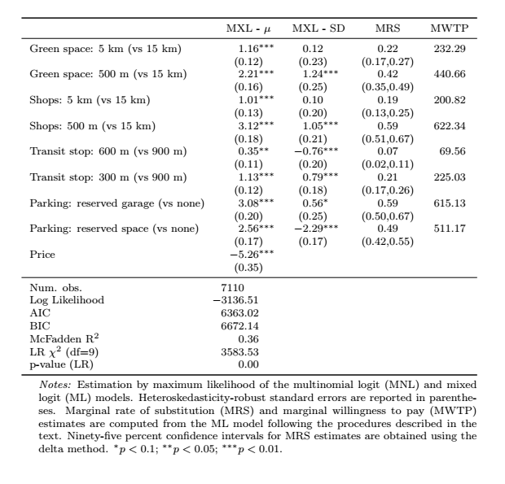
The MRS values are reported in column four and are computed as the ratio of attribute to price coefficients, following Equation XX. The corresponding MWTP values in column five are obtained by scaling the MRS by 10 percent of the average planned housing cost for each tenure group, as described in Equation YY.
As shown in Table 3, homeowners are willing to pay 440 SEK per month more to avoid living 15 km from the nearest green area and roughly 620 SEK per month to live within 500 m of shops. Access to parking is also highly valued, with MWTP estimates of 615 SEK for a reserved garage and 511 SEK for a reserved parking space, compared to no reserved parking. These results generally suggest a comparatively greater preference for proximity to shops and secure parking options.

Table 4
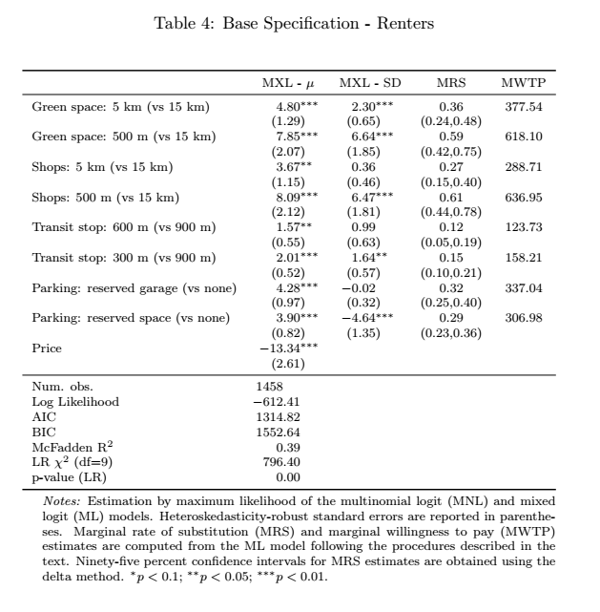
Turning to renters, Table 4 reveals similar preference patterns but with generally lower MWTP magnitudes. Renters are willing to pay 618 SEK per month to reside within 500 m of green space and 637 SEK for proximity to shops within 500. These values remain economically meaningful yet modestly below those of owners. Renters also show strong preferences for parking access, although their MWTP for a reserved garage (337 SEK) or space (307 SEK) is roughly half that of homeowners.
Overall, the base specification results demonstrate robust and consistent patterns of residential preferences. The strong fit of the mixed logit models, along with significant random parameter estimates, supports their use as the preferred framework for the heterogeneity analyses that follow.

Heterogeneity model results

Age Heterogeneity
To assess whether preferences differ among the oldest respondents, mixed logit models were estimated with interaction terms between all housing attributes and a dummy variable equal to one for individuals aged 75 years or older. The main effects capture preferences for respondents under 75, while interaction coefficients indicate whether the marginal utilities differ for the 75+ group. MWTP values are calculated for each group separately as the ratio of the attribute to price coefficient.
Table 5 reports the results. Among homeowners under 75, proximity to amenities generates strong and statistically significant utility gains. The baseline MWTPs are 426 SEK a month for green space within 500 m (vs 15 km), 515 SEK for shops within 500 m, and 558 SEK for a reserved garage.
For homeowners aged 75 and older, we see that the coefficient for green space × 75+ is negative (−0.68, p < 0.05), indicating that older homeowners derive less marginal utility from nearby green areas than younger respondents. The corresponding MWTP for green space within 500 m is 407 SEK a month, lower than the younger baseline group.
In contrast, the coefficient transit stop × 75+ is positive (0.47, p < 0.05), suggesting that the oldest homeowners place greater value on transit accessibility. Their MWTP for a 600 m transit stop is approximately 138 SEK a month, compared with 21 SEK for younger respondents. These results imply that while overall preference patterns are stable across age groups, the relative importance of green space and public transport accessibility shifts modestly among homeowners aged 75+.
Among renters under 75, MWTPs mirror those of homeowners in relative terms: 489 SEK for green space within 500 m, 518 SEK for shops within 500 m, and 286–323 SEK for parking amenities. We observe that renters aged 75+ value proximity to shops to a lesser extent than their younger counterpart with a MWTP of 446 SEK compared to 518 SEK. Other interactions, including those for green space, transit, and parking, are statistically insignificant, although MWTP values remain positive, suggesting continued but more modest preferences for these amenities.
Both specifications demonstrate good fit. The homeowner model yields a log-likelihood of −3125.21 (McFadden R² = 0.37), and the renter model −610.58 (R² = 0.40). Likelihood-ratio tests reject the null of no interaction effects (p < 0.001 for both models), confirming that age heterogeneity contributes significantly to explaining observed choice behavior. However, no distinct patterns were observed in how older renters and homeowners value the various residential attributes examined in our choice experiment compared to their younger counterparts.

Table 5- Interaction Regression - 75+
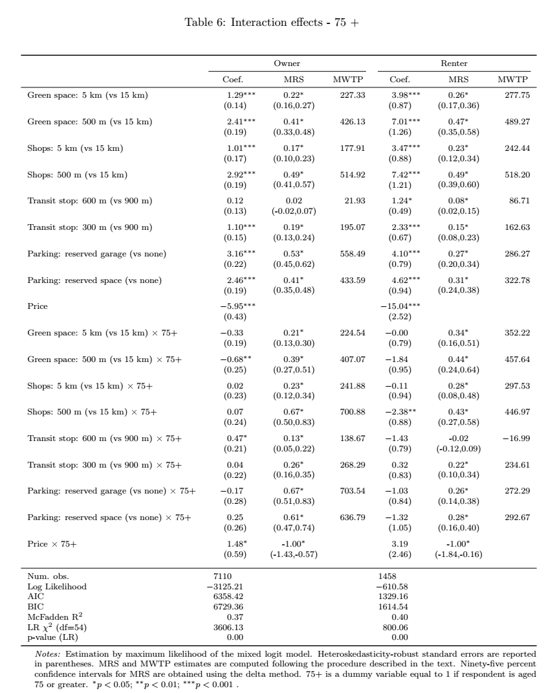

Gender
Gender differences in housing preferences were tested using mixed logit models with interactions between all housing attributes and a male indicator variable (Men = 1). Main effects represent female preferences, and interaction terms denote male deviations. MWTPs for men and women were obtained separately as the ratio of attribute to price coefficients for each group.
As shown in Table 6, female homeowners show strong and statistically significant preferences for proximity-based amenities. The corresponding MWTPs are 492 SEK/month for green space within 500 m, 653 SEK for shops within 500 m, and 428–542 SEK for parking amenities. Male homeowners prioritize proximity to shops, with MWTP values 75 SEK greater than female homeowners. Parking availability is also prioritized by male homeowners, who demonstrate much stronger preferences for reserved parking facilities than women (529-644 SEK vs 428-542 SEK). Compared to female homeowners, males value proximity to green spaces to a lesser extent with a MWTP value of 351 SEK.
Among renters, coefficient estimates reveal no statistically significant gender interactions. The main effects for female renters indicate positive and significant preferences for proximity to green space and shops, with corresponding MWTPs of roughly 434–437 SEK a month. Male renters’ coefficients are directionally similar, though MWTP magnitudes are modestly higher (490 SEK for green space and 619 SEK for shops), indicating consistent but not statistically distinct preferences.
The results suggest that gender differences in housing preferences are limited in statistical terms, though some systematic patterns are evident. Among homeowners, men show weaker preferences for green space but stronger preferences for shop proximity relative to women. Parking MWTPs are demonstratively higher for men while transit accessibility appears gender-neutral. The consistency of results across tenure groups indicates that gendered patterns in housing choice are modest in magnitude, with significant variation only for specific amenity types.

Table 6 - Interaction Regression - Sex
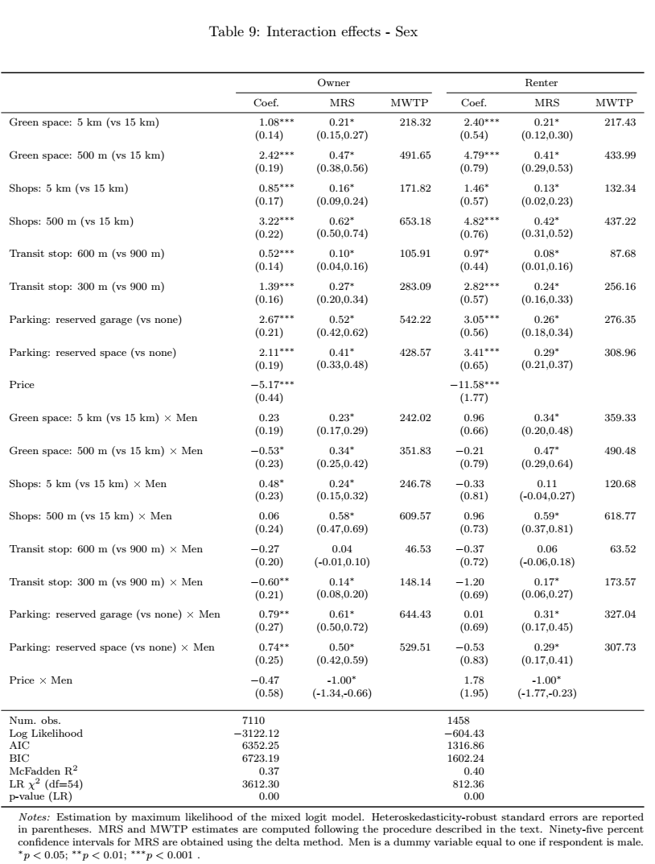

Health
In Table 7, we present the results for tests including interactions terms of attributes and health (coded as 1 for "good" or better health; reference = fair/poor). For homeowners, those reporting good or better health place less importance on distance to transportation, expressing MWTP values that are about one third of those with fair/poor health (54 SEK vs 177 SEK). Several other coefficients differ by health status, though few reach conventional significance thresholds.
Among renters, no interaction coefficients are statistically significant. Nonetheless, MWTPs suggest similar patterns: renters in good health exhibit somewhat higher valuations for green space and public transport, whereas those in poorer health show elevated MWTP for parking convenience. These effects are modest in magnitude and imprecisely estimated, likely due to smaller sample size and limited variation in self-reported health among renters.
The health heterogeneity results indicate that preference structures vary with physical condition, though most differences are not statistically significant. Healthier respondents display higher valuations for attributes that support outdoor activity and local engagement, while those in poorer health prioritize accessibility and convenience features. These patterns suggest that health status influences housing attribute trade-offs in predictable ways, even if the estimated differences are not statistically strong.

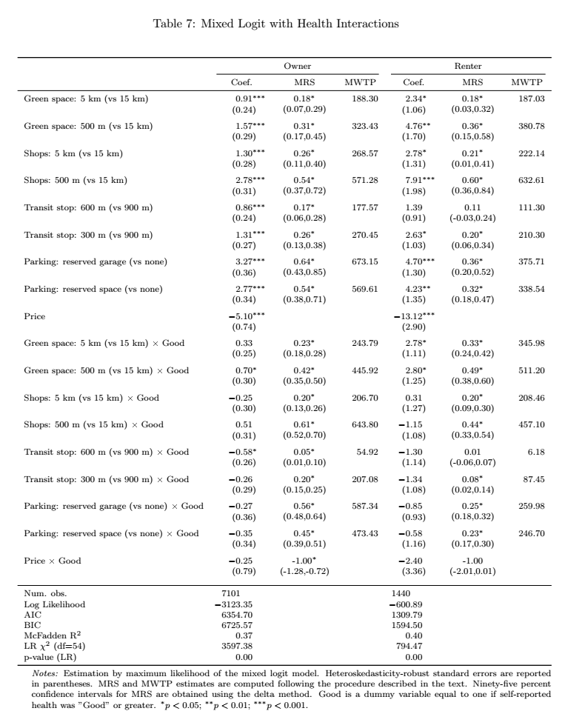

Discussion – WORK IN PROGRESS
This study examined how older adults in Sweden value key residential location attributes and how these preferences vary by age, gender, and health. Using discrete choice data analyzed through mixed logit models, we identified clear preferences for proximity to green areas, shops, and public transport, as well as access to dedicated parking. These findings confirm that accessibility and convenience are central elements of residential utility in later life, shaping how individuals assess relocation options.
Compared with previous research, our results align closely with findings from Ossokina and Arentze (2022), who reported that proximity to shops and public transport significantly influenced relocation decisions among older adults. However, our study extends this evidence to a larger and more diverse sample, encompassing both homeowners and renters actively considering relocation. This focus strengthens the behavioral validity of the results, as participants’ choices reflect genuine decision contexts rather than hypothetical scenarios. The Swedish setting also contributes new evidence from a Nordic welfare context where ageing-in-place policies are well established but empirical valuation studies remain scarce.
The results show that while broad preference patterns are consistent across groups, notable differences emerge with age and health. Older homeowners value proximity to public transport more and green areas less than younger counterparts, suggesting that mobility support becomes more critical as physical capacity declines. Among renters, the oldest respondents place less importance on nearby shops, perhaps reflecting adaptive behaviors such as reduced shopping frequency or increased reliance on home delivery services. Gender differences are modest: men express higher willingness to pay for parking and shop proximity, whereas women value green space slightly more. Differences by health status also follow intuitive patterns, with individuals in poorer health attaching greater importance to features that facilitate mobility and convenience.
These findings indicate that while demographic and health factors influence housing preferences, much of the observed heterogeneity remains unexplained, likely reflecting variation in lifestyle, social networks, and prior housing experience. From a policy perspective, this underscores the need for flexible, inclusive housing design that accommodates diverse forms of mobility and accessibility. Both private and public transport access remain essential to maintaining autonomy and wellbeing in later life. The comparatively lower valuation of green space among the oldest adults should not be interpreted as disinterest but rather as an indication of physical or environmental barriers limiting use. Enhancing the accessibility of green areas through features such as level surfaces, seating, lighting, and safe crossings could help sustain engagement with outdoor environments.
Several limitations warrant consideration. The study sample consists of individuals already registered for relocation services, who may differ from the broader older population in motivation or socioeconomic profile. The attribute set focuses on locational factors, excluding dwelling-level characteristics such as size, accessibility, and interior adaptability. The monetary estimates are context-specific and may vary across housing markets. Finally, the cross-sectional design limits the ability to assess changes in preferences over time. Future research should apply longitudinal and mixed-method approaches to capture how shifting health, financial, and social circumstances influence residential choices.

Conclusion WORK IN PROGRESS
This study provides new evidence on the residential preferences of older adults in Sweden, demonstrating that accessibility, proximity, and convenience are key determinants of housing choice in later life. Proximity to shops and services, green space, public transport, and parking consistently enhance perceived housing value, though their relative importance differs across demographic and health groups. The oldest respondents and those with poorer health place greater emphasis on transit accessibility, while men prioritize parking more than women. These results suggest that mobility, whether through public or private means, remains central to preserving independence and quality of life among ageing populations.
For policymakers and planners, the findings highlight the importance of creating age-inclusive residential environments that integrate transit-oriented and walkable design principles. Developments combining accessible public transport, local services, and barrier-free outdoor environments can deliver significant welfare benefits for older adults. The study also emphasizes that while preferences are diverse, the shared emphasis on mobility and accessibility offers a common foundation for designing flexible housing and neighborhood strategies.
Future research should build on this framework by integrating longitudinal data and revealed-preference measures to examine how preferences evolve as individuals transition through different stages of later life. Such work will be essential for ensuring that housing policies and urban planning initiatives remain responsive to the changing needs of ageing societies.

References
Abramsson, M., & Andersson, E. K. (2012). Residential Mobility Patterns of Elderly—Leaving the House for an Apartment. Housing Studies, 27(5), 582–604. https://doi.org/10.1080/02673037.2012.697553
Abramsson, M., & Andersson, E. K. (2015). Changing locations: Central or peripheral moves of seniors? Journal of Housing and the Built Environment, 30(4), 535–551. https://doi.org/10.1007/s10901-014-9427-0
Aitken, D., Willis, K., & Gilroy, R. (2024). Do older homebuyers prefer dwellings with accessibility and adaptability features? Findings from an exploratory study. Housing Studies, 39(3), 608–630. https://doi.org/10.1080/02673037.2022.2060944
Alsnih, R., & Hensher, D. A. (2003). The mobility and accessibility expectations of seniors in an aging population. Transportation Research Part A: Policy and Practice, 37(10), 903–916. https://doi.org/10.1016/S0965-8564(03)00073-9
Ardeshiri, A., Washington, L., Vij, A., Leishman, C., & Beer, A. (2024). Housing preferences for owner-occupied versus investment properties in Sydney, Australia. Housing Studies, 0(0), 1–23. https://doi.org/10.1080/02673037.2024.2428749
Caplan, A. J., Akhundjanov, S. B., & Toll, K. (2021). Measuring heterogeneous preferences for residential amenities. Regional Science and Urban Economics, 87, 103646. https://doi.org/10.1016/j.regsciurbeco.2021.103646
Clark, W., Deurloo, M., & Dieleman, F. (2006). Residential Mobility and Neighbourhood Outcomes. Housing Studies, 21(3), 323–342. https://doi.org/10.1080/02673030600585946
Cohen-Cline, H., Turkheimer, E., & Duncan, G. E. (2015). Access to green space, physical activity and mental health: A twin study. Journal of Epidemiology and Community Health, 69(6), 523–529. https://doi.org/10.1136/jech-2014-204667
DeShazo, J. R., & Fermo, G. (2002). Designing Choice Sets for Stated Preference Methods: The Effects of Complexity on Choice Consistency. Journal of Environmental Economics and Management, 44(1), 123–143. https://doi.org/10.1006/jeem.2001.1199
Ewen, H. H., Hahn, S. J., Erickson, M. A., & Krout, J. A. (2014). Aging in Place or Relocation? Plans of Community-Dwelling Older Adults. Journal of Housing for the Elderly, 28(3), 288–309. sih. https://doi.org/10.1080/02763893.2014.930366
Helveston, J. P. (2023). logitr: Fast Estimation of Multinomial and Mixed Logit Models with Preference Space and Willingness-to-Pay Space Utility Parameterizations. Journal of Statistical Software, 105(10). https://doi.org/10.18637/jss.v105.i10
Hensher, D. A., Rose, J. M., & Greene, W. H. (2015). Applied Choice Analysis (2nd ed.). Cambridge University Press. https://doi.org/10.1017/CBO9781316136232
Hildebrand, E. D. (2003). Dimensions in elderly travel behaviour: A simplified activity-based model using lifestyle clusters.
Himmler, S., Soekhai, V., van Exel, J., & Brouwer, W. (2021). What works better for preference elicitation among older people? Cognitive burden of discrete choice experiment and case 2 best-worst scaling in an online setting. Journal of Choice Modelling, 38, 100265. https://doi.org/10.1016/j.jocm.2020.100265
Lancsar, E., & Louviere, J. (2008). Conducting Discrete Choice Experiments to Inform Healthcare Decision Making: A User??s Guide. PharmacoEconomics, 26(8), 661–677. https://doi.org/10.2165/00019053-200826080-00004
Lee, P.-H., Han, Q., de Vries, B., & Juan, Y.-K. (2025). Heterogeneities in willingness to pay for circular affordable housing: Insight from young users. Housing Studies, 40(11), 2450–2480. https://doi.org/10.1080/02673037.2024.2404063
Lofqvist, C., Granbom, M., Himmelsbach, I., Iwarsson, S., Oswald, F., & Haak, M. (2013). Voices on Relocation and Aging in Place in Very Old Age—A Complex and Ambivalent Matter. The Gerontologist, 53(6), 919–927. https://doi.org/10.1093/geront/gnt034
Maas, J. (2006). Green space, urbanity, and health: How strong is the relation? Journal of Epidemiology & Community Health, 60(7), 587–592. https://doi.org/10.1136/jech.2005.043125
Mangham, L. J., Hanson, K., & McPake, B. (2009). How to do (or not to do) … Designing a discrete choice experiment for application in a low-income country. Health Policy and Planning, 24(2), 151–158. https://doi.org/10.1093/heapol/czn047
McFadden, D. (1974). The measurement of urban travel demand. Journal of Public Economics, 3(4), 303–328. https://doi.org/10.1016/0047-2727(74)90003-6
McFadden, D., & Train, K. (2000). Mixed MNL models for discrete response. Journal of Applied Econometrics, 15(5), 447–470. https://doi.org/10.1002/1099-1255(200009/10)15:5<447::AID-JAE570>3.0.CO;2-1
Nielsen, T. S., & Hansen, K. B. (2007). Do green areas affect health? Results from a Danish survey on the use of green areas and health indicators. Health & Place, 13(4), 839–850. https://doi.org/10.1016/j.healthplace.2007.02.001
Ossokina, I. V., & Arentze, T. A. (2022). Reference-dependent housing choice behaviour: Why are older people reluctant to move? Housing Studies, 1–19. https://doi.org/10.1080/02673037.2022.2151984
Ossokina, I. V., Arentze, T. A., Van Gameren, D., & Van Den Heuvel, D. (2020). Best living concepts for elderly homeowners: Combining a stated choice experiment with architectural design. Journal of Housing and the Built Environment, 35(3), 847–865. https://doi.org/10.1007/s10901-019-09716-5
Paquet, C., Orschulok, T. P., Coffee, N. T., Howard, N. J., Hugo, G., Taylor, A. W., Adams, R. J., & Daniel, M. (2013). Are accessibility and characteristics of public open spaces associated with a better cardiometabolic health? Landscape and Urban Planning, 118, 70–78. https://doi.org/10.1016/j.landurbplan.2012.11.011
Ricciardi, A. M., Xia, J., & Currie, G. (2015). Exploring public transport equity between separate disadvantaged cohorts: A case study in Perth, Australia. Journal of Transport Geography, 43, 111–122. https://doi.org/10.1016/j.jtrangeo.2015.01.011
Robison, J. T., & Moen, P. (2000). A Life-Course Perspective on Housing Expectations and Shifts in Late Midlife. Research on Aging, 22(5), 499–532. https://doi.org/10.1177/0164027500225003
Roy, N., Dubé, R., Després, C., Freitas, A., & Légaré, F. (2018). Choosing between staying at home or moving: A systematic review of factors influencing housing decisions among frail older adults. PLOS ONE, 13(1), e0189266. https://doi.org/10.1371/journal.pone.0189266
Schulz, M., Gross, C., & Teti, A. (2025). Owning, Renting and Environmental Proactivity: The Role of Housing Tenure in Hypothetical Housing Decisions.
Sturm, R., & Cohen, D. (2014). Proximity to Urban Parks and Mental Health.
Toth, M., Palmer, L., Bercaw, L., Voltmer, H., & Karon, S. L. (2022). Trends in the Use of Residential Settings Among Older Adults. The Journals of Gerontology: Series B, 77(2), 424–428. https://doi.org/10.1093/geronb/gbab092
Train, K. (Ed.). (2003). Discrete choice methods with simulation. Cambridge University Press.
United Nations Department of Economic and Social Affairs. (2023). World Social Report 2023: Leaving No One Behind in an Ageing World. United Nations. https://doi.org/10.18356/9789210019682
Wiles, J. L., Leibing, A., Guberman, N., Reeve, J., & Allen, R. E. S. (2012). The Meaning of “Aging in Place” to Older People. The Gerontologist, 52(3), 357–366. https://doi.org/10.1093/geront/gnr098
Zhao, L., Szajnfarber, Z., Broniatowski, D., & Helveston, J. P. (2023). Using conjoint analysis to incorporate heterogeneous preferences into multimodal transit trip simulations. Systems Engineering, 26(4), 438–448. https://doi.org/10.1002/sys.21670

